**Capstone - Alternative Cities: Lifestyles Analysis**

**Author/Analyst – Dale Hunter**

**Introduction/Business Problem**

With the current pandemic environment creating a WFH(Work From Home) environment for a majority of jobs, I wanted to analyze and create an engine that would allow looking at alternative locations for us to live that would allow us to be closer to venues we like (i.e. nice restaurants, parks, live music/theatre) and possibly closer to where our daughter may be attending college in 2021. Since WFH allows us not to be in the cities where are companies are, we can begin to expand ideas on where we might want to relocate. This could be utilized as the "engine" behind a GUI front-end for persons/families to pick their own city destinations and categories of venues for their decision-making process.

**Data**

I will be using the Foursquare API data to identify venues for 3 potential cities that may be where we might want to relocate based on our desire to be closer to our daughter's possible college choices and cities we've visited and like the general feel, but don't know much about the area, where we could live close to venues we like. As stated, we don't need to look at schools, but do like parks, restaurants, and music/entertainment venues. Also, we want to look at the housing costs, and the supply/demand of housing in that cities by zip code.

To do this, I will use the Foursquare data to get the venues (and categories) for the cities of Kansas City, Missouri (we live in a suburb of Kansas City, but would love to move downtown if we stayed once our daughter was off to college), Fort Collins, CO, and Portland, OR.

For the data on housing data, I will use data from Realtor.com (specifically, RDC_Inventory_Hotness_Metrics_Zip_History) that has current data (202004) on Housing inventory and hotness metric data that will supply the median_listing_prices, supply_score, demand_score, and median_listing_price_vs_us by zip code. This data will allow us to look at the three cities and compare the median housing price, the comparison to the median price to rest of US (our current zip code is a +2 from the median price in US), and a gauge on the supply/demand index calculated by Realtors.com (high # up to 100 is level of either category) to gauge the housing market in that city.

All this data will allow us to compare zip codes(areas) in those cities that would be best suited for starting a search as well as compare cities to help in our decision.

**Methodology**

Utilizing Foursquare API and Folium to render maps to visualize each city being researched. Then, clustered venue data to prioritize/identify areas in each city by venue category to illustrate zipcode that may contain venues that myself (or others) could explore related to places to live in that zipcode.

Wrangled “current” data from historical data set on realty data from Realtor.com. **NOTE**: See **appendix** for full citing documentation on that data and website. This data was then merged with the city venue data by postalCode to get a dataset to perform a bar chart comparison of the median housing prices.

**Results**

In using the Foursquare API and Folium maps, I determined that there were parks, theater/music venues, grocery shopping identified on the map although not all showed up in venue plotting. Therefore, one can also use that visually to get an additional “sense” of proximity to interests we (or others) may enjoy when researching where we could look to relocate.

***Kansas City, MO***

Mapping of the city provided a “birds-eye” view of general layout of the city and visual clustering of venue areas within the city.

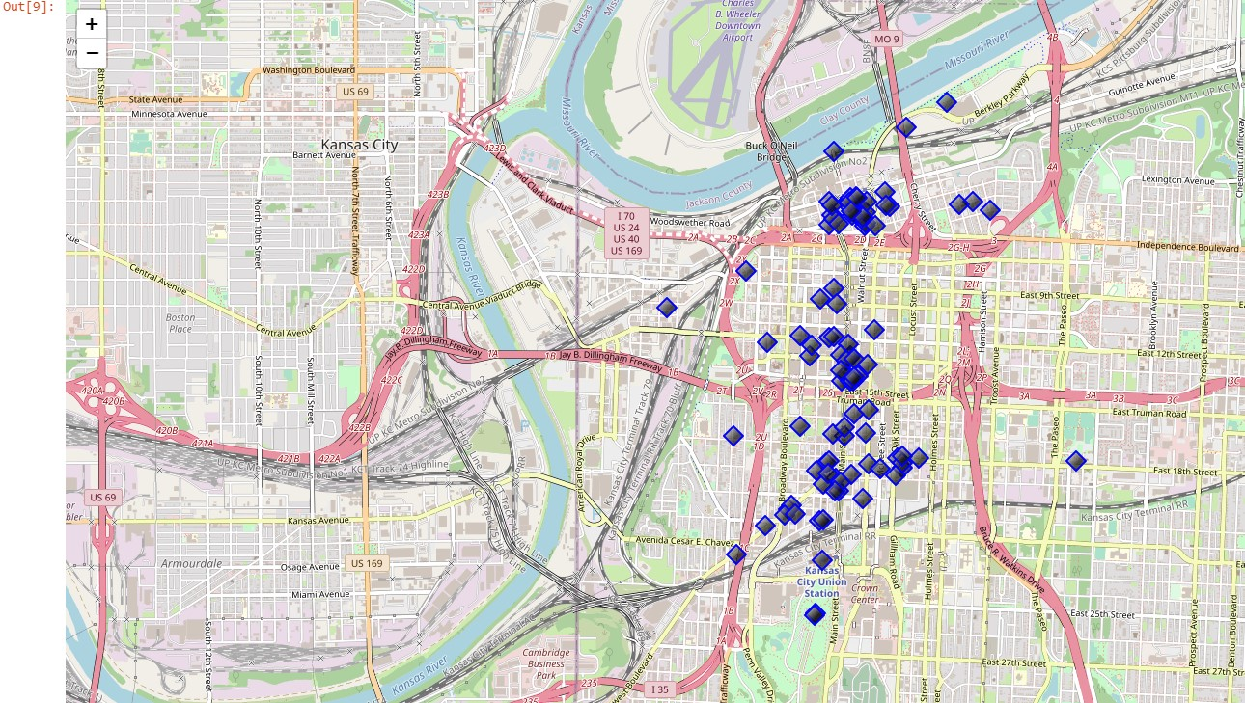

With the clustering of the venue data for each city, the following “results” were found:

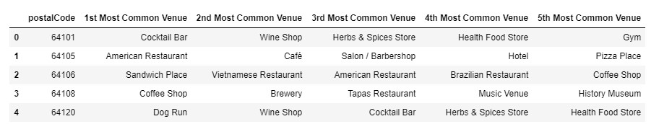

**As stated in the Introduction, we enjoy Parks and Music venues but also like Breweries and fun restaurants so we may begin looking at zipcode 64108 and then look at housing data.**

***Fort Collins, CO***

Mapping of the city provided a “birds-eye” view of general layout of the city and visual clustering of venue areas within the city.

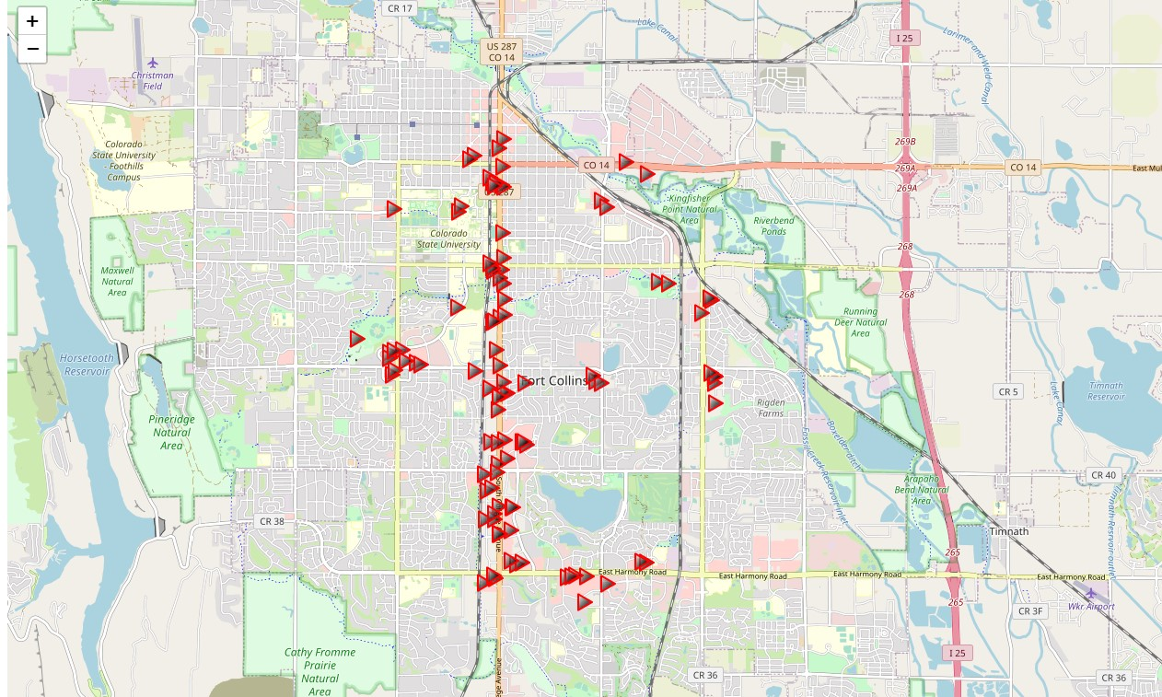

With the clustering of the venue data for each city, the following “results” were found:

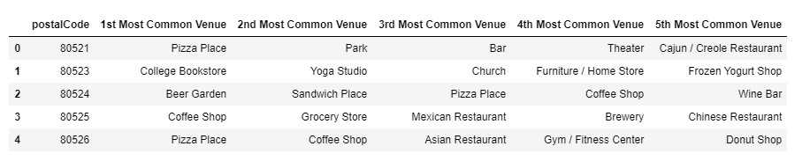

**As stated in the Introduction, we like Parks and Music/Theater venues so we may begin looking at zipcode 80521 and then look at housing data.**

***Portland, OR***

Mapping of the city provided a “birds-eye” view of general layout of the city and visual clustering of venue areas within the city.

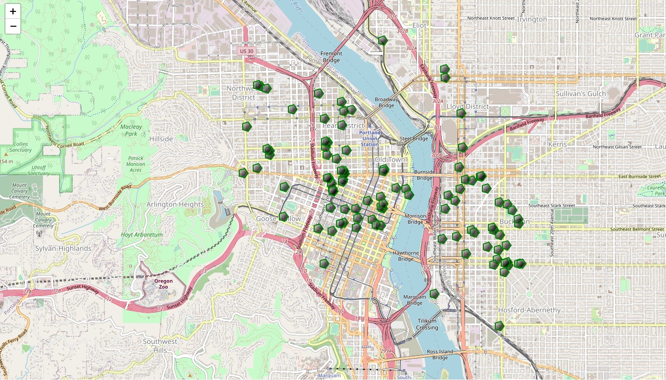

With the clustering of the venue data for each city, the following “results” were found:

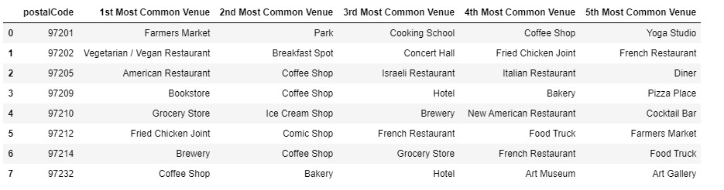

**Portland has diverse neighborhoods, so didn’t really have one area that stood out as an area to start, but with parks, restaurants, and even farmer’s markets, we have several to begin researching further by using the housing data.**

**Housing data**

**From a comparison of the median housing prices for each zip code. NOTE: For simplicity, the following assumptions were made when visualizing the zip code data: 64XXX = Kansas City, MO; 80XXX = Fort Collins, CO; and 97XXX = Portland, OR.**

**Below is a bar chart with the results of that data.**

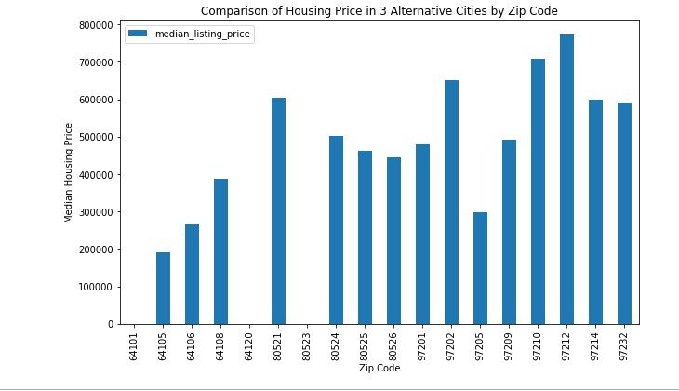

**Discussion/Recommendation**

Looking first at the housing price data, one can see that the prices in Kansas City, Missouri are generally quite a bit lower than the other 2 cities (outside of a few zip codes in those cities). Also, with so many factors that could also be analyzed relating to where one may want to live (i.e. crime rate, internet connectivity ranking, health care availability), further data sources could be added to this analysis to provide a more robust/flexible analytical toolset.

Based on the datapoints I investigated, I am excited to present this data to my family for further discussion on what next steps may be. I would also look at multiple sources for the housing data to determine if we can get a further “drill-down” on the type of housing as we are open to other housing than home ownership in our next chapter (and others may be in that same situation).

**Conclusion**

This analysis and the coding framework allows someone to have a “tool” to do the same comparison of other cities that come up in their research going forward. I would conclude based on the housing data that we will definitely be looking at Kansas City, MO first as we currently live in this area and are most familiar with all the city has to offer. Also, this would allow us to be able to not have to work remotely if office presence is more of a requirement once the pandemic has subsided.

**Appendix**

Housing data came from Realtor.com and specifically the “realtor.com market hotness index”. Reference: <https://www.realtor.com/research/data/>